## **LATAM @SingularityNET COMMUNITY**

## Milestone Deliverable #3

#### **Milestone Deliverable Title: Tailored Social Media Engagement.**

Milestone #3 Description: Develop a tailored social media plan for each country, utilizing platforms popular among local AI developers (e.g., LinkedIn, Twitter, Instagram). -Schedule regular posts featuring blog content, program updates, and AI-related news. -Engage with the audience through comments and direct messages.

## 

## **1. Content Strategy, operations and Platforms**

## General description and conclusion of this first phase of our social media content strategy:

Our content strategy development is focused on X [former twitter], LinkedIn and Medium. During the first month we had a problem with Medium [they blocked our account] and we used WordPress in the first phase of blogging. We have already solved the problem. For blog content we have also started using LinkedIn since their blogging tool is very good and reach analysis is important for audience development and alliance strategy. The final decision on the selection of social media platforms to develop has to do with the results of our research.(Milestone deliverable #1)

#### **Strategy for Validation, Quantification, and Engagement:**

Continuing with our conversion and engagement strategy, we set out after Round #4 to quantify the results on engagement of our social media content and the number of proposals in the new round that come from the efforts of @SNET_Latam.

#### 

#### Deliverables:

#### **Tailored media content:**

On the platforms you will find an example of tailored media content where we focus on generating valuable content promoting, @SingularityNET, the different Sipn Offs, the ecosystem and the different activities. We have created specific content for education, dissemination and training blogs. In #DeepFunding and in communication actions to disseminate the actions of the SNET Ambassadors program and all the activities within the ecosystem.

#### **Situation Status by platform:**

#### **X [Former Twitter]**

#### <https://twitter.com/SNET_Latam>

X [Former Twitter] Is the social media platform of our preference, being the space for information exchange and its algorithm is today the best tool for dissemination. Its cross-platform integration capacity has been our best tool to achieve engagement and thus spread and amplify our messages, promote our different online events and content. We joined October 2023; to date we have had organic growth with 171 Followers and we have made 647 posts.

**Highlights:** We have achieved the engagement peaks with our blogs, notes and reviews written by our specialists. Our promotion posts for the @SNET_Latam Town Halls and with our knowledge dissemination and training blogs.

#### **Linkedin**

#### <https://www.linkedin.com/showcase/101002044/admin/feed/posts/>

Linkedin has proven to be an excellent platform to reach users in their specific areas of professional development since the algorithm is developed in an area of interest for our strategy of amplifying the message and vision of 2singularityNET to specific audiences in the area of technological development and start-up professionals.

**Linkedin Articles:** We have started using platform Articles replicating our BLOG content, this powerful platform gives us the opportunity to quantify and generate analytical data about the interaction and gives us the opportunity to generate a user base interested in the generated content. Joined October 2023; To date we have had organic growth with 50 Followers.

The following link contains a spreadsheet with the analytics from March 29 to April 27, 2024 [snet-latam_content_1714409086669](https://docs.google.com/spreadsheets/d/1nvc5d_q27NizAQKeP09-k0lwBWXa6wSoUCserG1CYHc/edit?usp=sharing)

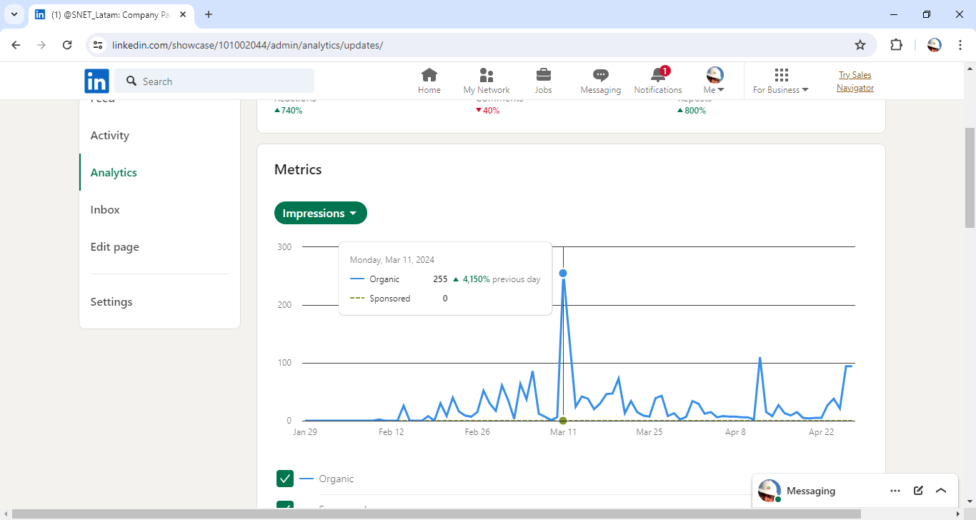

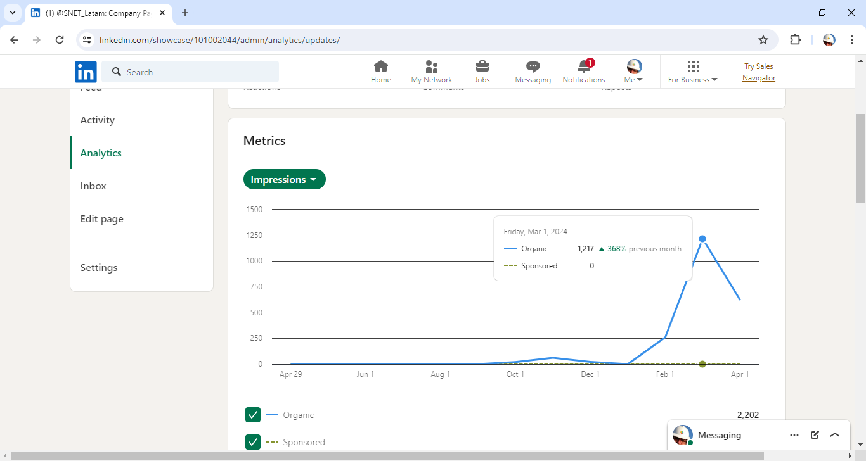

#### 

#### **Medium**

#### <https://medium.com/@singularitynet-latam>

Medium has been our platform of choice for blog content, despite a beginning with blocking problems, with the help of the user service team we have managed to solve the problem and today we have reactivated the dissemination strategy on this social network of knowledge.

We have managed to resume the initiative and have published our last two articles on the platform about:

* *RFPs: Building Together*

We invite you to explore what an RFP is and how it works, become an expert in Submitting Proposals for the next #4 Round of Deep Funding!

* *Deep Funding Round #4 is here!*

Deep Funding is back with its fourth round of funding and more determined than ever to boost SingularityNET's decentralized AI platform.

What matters most about the platform is being able to link our users with the different creators of content and knowledge of the ecosystem, with the aim of generating transversal engagement that benefits all members of the community.